**Case :**

1. **Desain IP VLSM dengan ketentuan dibawah menggunakan configurasi switch**

Sebuah perusahaan swasta memiliki 5 divisi masing-masing:

Divisi HRD membutuhkan 14 user

Divisi Marketing membutuhkan 28 user

Divisi Financial membutuhkan 18 user

Divisi Teknisi Gangguan membutuhkan 90 user

Divisi Operator dan Administrasi membutuhkan 20 user

1. **Desain IP VLSM untuk keperluan ruangan pada denah**

**Solving:**

**Tabel Subnet untuk mempermudah:**

|  |  |  |  |  |  |  |  |  |
| --- | --- | --- | --- | --- | --- | --- | --- | --- |
| **Pangkat (2^x)** | 7 | 6 | 5 | 4 | 3 | 2 | 1 | 0 |
| **Desimal** | 128 | 64 | 32 | 16 | 8 | 4 | 2 | 1 |
| **Subnetmask** | 128 | 192 | 224 | 240 | 248 | 252 | 254 | 255 |
| **Prefik** | /25 | /26 | /27 | /28 | /29 | /30 | /31 | /32 |
| **Host** | 126 | 62 | 30 | 14 | 6 | 2 | 0 | - |

1. Tabel VLSM

|  |  |  |  |  |  |  |
| --- | --- | --- | --- | --- | --- | --- |
| Divisi | Jml User | Subnet | Network ID | Rentang Host | | Broadcast |
| Teknisi dan Gangguan | 90 | /25 | 192.168.100.0 | 192.168.100.1 | 192.168.100.126 | 192.168.100.127 |
| Marketing | 28 | /27 | 192.168.100.128 | 192.168.100.129 | 192.168.100.158 | 192.168.100.159 |
| Operator dan Administrasi | 20 | /27 | 192.168.100.160 | 192.168.100.161 | 192.168.100.190 | 192.168.100.191 |
| Financial | 18 | /27 | 192.168.100.192 | 192.168.100.193 | 192.168.100.222 | 192.168.100.223 |
| HRD | 14 | /28 | 192.168.100.224 | 192.168.100.225 | 192.168.100.238 | 192.168.100.239 |

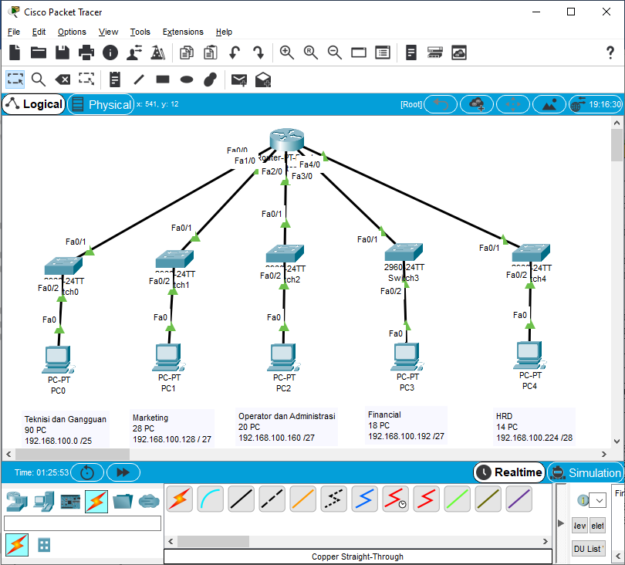

1. Desain IP address sesuai dengan kebutuhan host di masing-masing ruangan

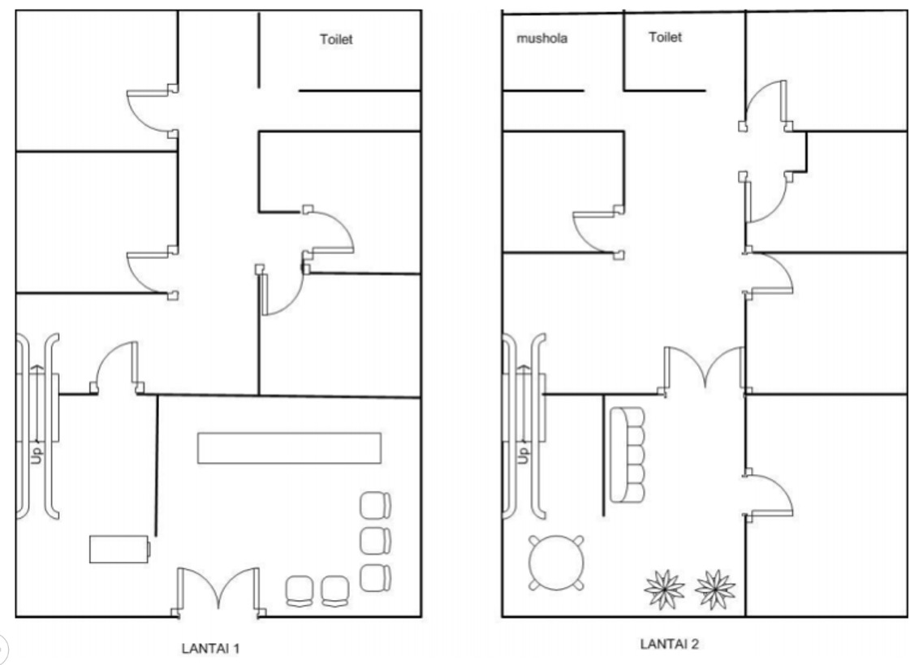

**5 PC**

**10 PC**

**10 PC**

**10 PC**

R 1.2

R 1.3

**2 PC**

**5 PC**

**5 PC**

**4 PC**

**10 PC**

**4 PC**

R 1.1

R 2.6

R 2.5

R 2.4

R 2.3

R 2.2

R 2.1

R 1.5

R 1.4

|  |  |  |  |  |  |  |
| --- | --- | --- | --- | --- | --- | --- |
| Kode Ruangan | Jml User | Subnet | Network ID | Rentang Host | | Broadcast |
| AP L1.1 | 20 | /27 | 192.168.100.0 | 192.168.100.1 | 192.168.100.30 | 192.168.100.31 |
| AP L1.2 | 20 | /27 | 192.168.100.32 | 192.168.100.33 | 192.168.100.62 | 192.168.100.63 |
| AP L2.1 | 20 | /27 | 192.168.100.64 | 192.168.100.65 | 192.168.100.94 | 192.168.100.95 |
| AP L.2.2 | 20 | /27 | 192.168.100.96 | 192.168.100.97 | 192.168.100.126 | 192.168.100.127 |
| R. 1.2 | 10 | /28 | 192.168.100.128 | 192.168.100.129 | 192.168.100.142 | 192.168.100.143 |
| R. 1.3 | 10 | /28 | 192.168.100.144 | 192.168.100.145 | 192.168.100.158 | 192.168.100.159 |
| R. 1.4 | 10 | /28 | 192.168.100.160 | 192.168.100.161 | 192.168.100.174 | 192.168.100.175 |
| R. 2.3 | 10 | /28 | 192.168.100.176 | 192.168.100.177 | 192.168.100.190 | 192.168.100.191 |
| R. 1.5 | 5 | /29 | 192.168.100.192 | 192.168.100.193 | 192.168.100.198 | 192.168.100.199 |
| R. 2.5 | 5 | /29 | 192.168.100.200 | 192.168.100.201 | 192.168.100.206 | 192.168.100.207 |
| R. 2.6 | 5 | /29 | 192.168.100.208 | 192.168.100.209 | 192.168.100.214 | 192.168.100.215 |
| R. 2.2 | 4 | /29 | 192.168.100.216 | 192.168.100.217 | 192.168.100.222 | 192.168.100.223 |
| R. 2.4 | 4 | /29 | 192.168.100.224 | 192.168.100.225 | 192.168.100.230 | 192.168.100.231 |
| R. 1.1 | 2 | /30 | 192.168.100.232 | 192.168.100.233 | 192.168.100.234 | 192.168.100.235 |
| R. 2.1 | - | - | - | - | - | - |

